*Use Case:*

Title: Send notification when anomaly is detected

Description

* The Augur workers, for example, the insights worker, are able to detect anomalies in the behavior within a repository. When one is detected, the worker will trigger the Zapier API to run an action to send a notification to a Slack channel, where the user will be notified.

Triggers

* Augur user sets up Zapier notifications in Slack for a given GitHub repository from Augur
* Augur worker detects anomalous behavior from that given GitHub repository.

Actors

* Augur User
* Insight worker

Preconditions

* GitHub repository must have a trend that the worker has detected
* Augur instance must be linked to Zapier
* User must have a Slack channel that notifications can be sent to
* Notifications must be turned on for a given worker

Main Success Scenario (Goals)

* User is notified of anomalous behavior from the Slack channel and is able to view relevant information from the notification itself

Alternate Success Scenarios

* None

Failed End Condition

* Zapier isn’t linked and so an error message is logged.
* The worker that detects anomalies isn’t running or working correctly

Extensions

* Send email alerting Augur users of anomalies.

Steps of Execution (Requirements)

1. Augur worker detects anomalous behavior
2. Worker gets relevant data and pushes it to endpoint on Augur API
3. Zapier gets data from endpoint and formats it for a notification
4. Notification is sent to Slack channel

Use Case Diagram

* 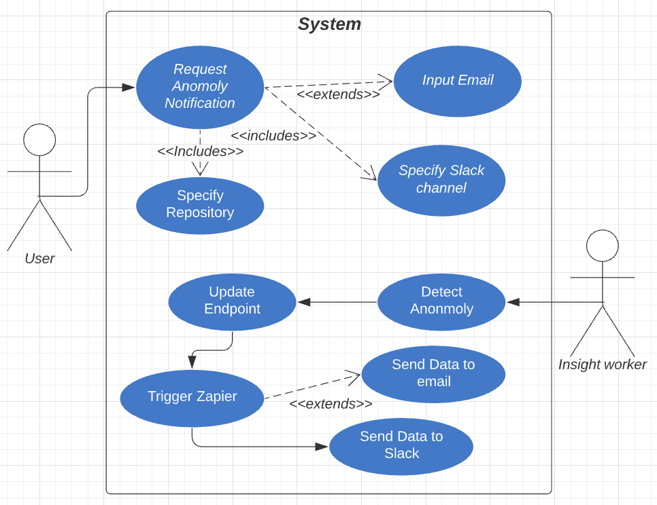

Dependent Use Cases

* None